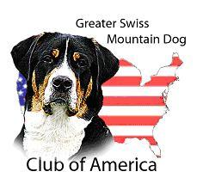
Working Pack Hike Event
Handler Entry Form
Hike date ________________________________
Registered Name
AKC Registration # |  |  | DOB: | Call Name:
Sire’s Registered Name
Dam’s Registered Name
Names of Owners
Address of Owner
Name of Handler
(if different from owner)
Location of Pack Event |  |  |  | Entry Fee:
Description of Hike
Weight of Dog: | Weight Carried: |  | Percent Carried: | Title:
Pack Dog Events are a strenuous physical activity. The owner and handler of registered dog accepts full responsibility for the conditioning and condition of both dog and human participant. The Greater Swiss Mountain Dog Club of America will not be held liable for any injuries occurred to either dog or humans.
I certify that I have completed the required prerequisite 6 mile training hike with full pack weight as specified in the GSMDCA Pack Hike Regulations.
Signature of Owner/ Handler:
For Pack Event Coordinator only
Name:
Address:
E-mail:
Signature:
First and foremost hikes are to be conducted with the safely and well-being of the GSMDs and handlers in mind. The Hike Coordinator is authorized to make any necessary decision, including disqualification, to protect the safety and well-being of the GSMDs and handlers.
Handlers—Please keep this form until you have the required number of legs for a title. This form is proof that you successfully completed a leg. When you have completed the required number of legs for a title, please submit using the online new title webform on the GSMDCA website.

